**Assignment 14**

**Task 1. Create a new Power BI report and load the data from the Excel file provided. In model view, create the obvious relationships between the tables.**

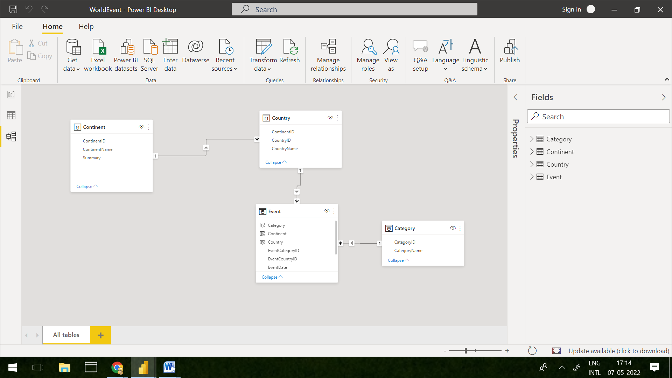

**Task 2. Using the RELATED function, create calculated columns in the Event table to bring in the country, continent and category for each event to get this:**

Upon using following formula, we can create these calculated columns in Event Table

Category = IF(RELATED(Category[CategoryID]) == Event[EventCategoryID], RELATED(Category[CategoryName]),BLANK())

Continent = IF(Event[EventCountryID]==RELATED(Country[CountryID]),RELATED(Continent[ContinentName]),BLANK())

Country = IF(RELATED(Country[CountryID]) == Event[EventCountryID], RELATED(Country[CountryName]),BLANK())

**Task 3. Create a matrix to show the number of events and continent.**

